Name : AYUSH ANAND
User_id : 55952
Computer Archituecture :
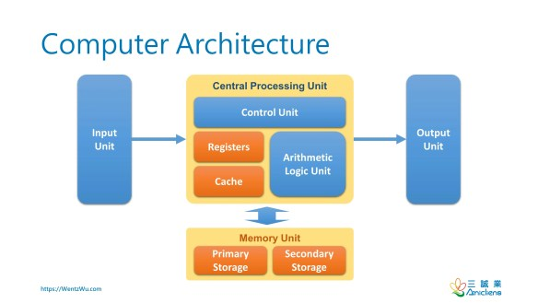
The design structure of a computer system that specifies how hardware and software work together is referred to as computer architecture. It covers how parts like the CPU, memory, input/output systems, and data pathways are arranged. It establishes the functionality, efficiency, and performance of the system.
Computer architecture consists of:
- CPU : handles data processing and instruction execution.
- Memory units : Stores instructions and data (RAM, cache, registers).
- I/O Devices : Communication between the computer and the outside world is made possible by input/output (I/O) devices.
- Data Path and Buses : Transfer signals and data between components (control bus, data bus, address bus).
CPU and Cores :
CPU is the central processing unit and core is an independent processing unit within the CPU.
Key performance factors are :
Clock Frequency : Determines how many instructions the CPU can execute per second.
Number of Cores : More cores allow better multitasking and parallel processing.
Cache hierarchy : Fast onboard memory (L1, L2, L3) that reduces data access time. A Central Processing Unit (CPU) is the brain of the computer responsible for executing instructions. It performs arithmetic, logical, control, and input/output operations.
CPU components include :
ALU (Arithmetic Logic Unit): Performs mathematical and logical operations.
CU (Control Unit): Directs operations of the processor.
Registers: Small, fast storage inside CPU.
Cache: High-speed memory within the CPU.
Multi-core Benefits
Multiple cores are are in the CPU which is highly beneficial . Some of it’s benefits are:
Multi-core Benefits
- Improved performance
- Better multitasking
- Efficient power usage
- Enhanced parallel execution
RAM (Random Access Memory) :
Ram is used to determine how many applications can run simultaneously and
reduces load on disk.
HDD (Hard Disk Drive): Magnetic storage, slower but cheaper; used for long-term storage.
SSD (Solid State Drive): Faster, uses flash memory; significantly reduces boot and load times.
Storage devices work alongside RAM, but RAM is much faster and is meant for temporary data while programs run. (Random Access Memory) RAM is a type of volatile memory that temporarily stores data and instructions currently being used by the CPU.
Cache Memeory :
Cache is a temporary storage used to quickly access frequently used data. Instead of fetching data again and again from a slow source (like a database, server, or disk), cache stores a copy of the data in a faster memory (RAM, browser memory, etc.).
Think of cache like keeping your most used things on your desk so you don’t go to the cupboard every time.
Desk = cache (fast access)
Cupboard = main storage/database (slow access)
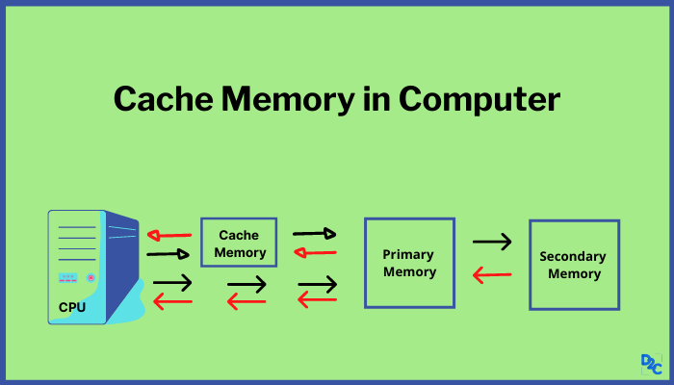
Cache Benefits :
1.Reduces CPU waiting time
2.Improves system performance
3.Helps multi-core CPUs share data efficiently

